Pizza Sales SQL Query

A.KPI’S

1.Total Revenue:

select sum(total_price) as Total_Revenue from pizza_sales;



2.Average order Value:

select sum(total_price)/count(distinct order_id) as Average_ord_value from pizza_sales;



1. Total Pizzas Sold:

Select sum(quantity) as Total_Pizza_sold from pizza_sales



1. Total Orders:

select count(distinct order_id) as Total_orders from pizza_sales



1. Average Pizzas Per Order:

select Cast (sum(quantity) as decimal(10,2)) /cast (count(distinct order_id) as decimal(10,2)) as Average_orders from pizza_sales



**B--Hourly Trend for totoal Pizzas sold**

Select DATEPART(Hour,order_time) as order_hour, sum(quantity) as Total_Pizzas_sold

from pizza_sales

Group by DATEPART(Hour,order_time)

order by DATEPART(Hour,order_time) ASC;

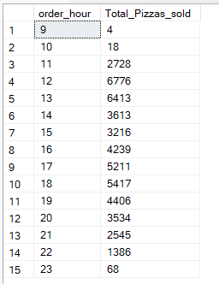

**C--- Weekly Trend for Total order**s

Select DATEPART(ISO_Week, Order_date) as week_order,Year(order_date) as year, count(distinct order_id) as Total_orders from pizza_sales

group by DATEPART(ISO_Week, Order_date),Year(order_date)

order by DATEPART(ISO_Week, Order_date), Year(order_date)

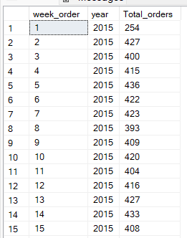

**D--Monthly Trend for Total order**

Select DATEPART(Month,order_date) as Order_Month, year(order_date) as year, count(Distinct order_id) As total_orders

from pizza_sales

group by DATEPART(Month,order_date), year(order_date)

order by DATEPART(Month,order_date), year(order_date) Asc;

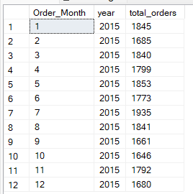

**E--Percentage of sales by Pizza Category for first month**

select pizza_category,cast(sum(total_price) as decimal (10,2)) as total_price, cast(sum(total_price)*100/(select sum(total_price) from pizza_sales Where month(order_date)=1) as decimal(10,2)) as Percentage_of_sales

from pizza_sales

Where month(order_date)=1

group by pizza_category;

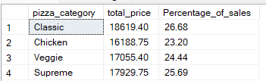

**F--Percentage of sales by Pizza Size - first quarter**

select pizza_size, count(pizza_size) as total_orders, cast(sum(total_price) as decimal (10,2)) as total_price, cast(sum(total_price)*100/(select sum(total_price) from pizza_sales Where datepart(quarter,order_date)=1) as decimal(10,2)) as Percentage_of_sales

from pizza_sales

where datepart(quarter,order_date)=1

group by pizza_size

order by Percentage_of_sales desc;

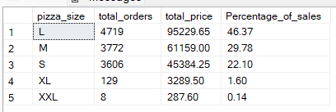

G----Top 5 selling Pizza Name -price

select top 5 pizza_name, sum(total_price) as Total_revenue

from pizza_sales

group by pizza_name

order by Total_revenue Desc;

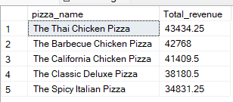

**H--Bottom 5 selling Pizza Name - price**

select top 5 pizza_name, sum(total_price) as Total_revenue

from pizza_sales

group by pizza_name

order by Total_revenue Asc;

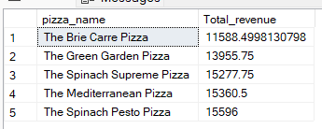

**G---Top 5 selling Pizza Name - quantity**

select top 5 pizza_name, sum(quantity) as Total_quantity

from pizza_sales

group by pizza_name

order by Total_quantity Desc;

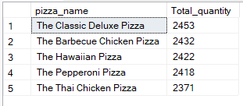

**H--Bottom 5 selling Pizza Name - price**

select top 5 pizza_name, sum(quantity) as Total_quantity

from pizza_sales

group by pizza_name

order by Total_quantity Asc;

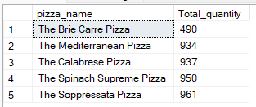

**I---Top 5 selling Pizza Name - order_id**

select top 5 pizza_name, count(distinct order_id) as Total_order

from pizza_sales

group by pizza_name

order by Total_order Desc;

